11TH DRMC national SCIENCE CARNIVAL

Line follower ROBOT competition

THE RULEBOOK

**General**​​**Rules:**

* The participants of this competition must be registered under a team. A team must have ​a​ team​ name​ and​ a team​ leader.​ A​​ ​team​ can​​ have​ maximum​ **4** ​**members**.​
* The teams have to make an autonomous line follower robot that follow black lines on the white surface under various conditions.​
* The contest will have two rounds - Primary Round and Final Round. A limited number of teams will be selected for the Final round based on total points of the Primary round.
* Number of teams selected for the Final round will be decided on the competition day based on the number​ of​ participating​ teams.​
* Primary round consist of basic line following challenges which include curved lines, intersections, ​right​ ​angles​ (90​ degree​ turn),​ ​​acute ​ angles.​
* In Final round, the qualified robots will have to cross line gap, a bridge and avoid an obstacle​ along​ ​with​​ the​​ challenges​ of​​ the​ Primary​ ​round.
* Number of checkpoints and the time limit will be declared on the competition day.
* The ​ winning​ ​ team​ ​ is​ ​ declared​ ​ based​ ​ on​ ​ the​​ points.​
* Each ​ team​ ​ has​ ​ **5** ​ **restarts**​ ​ for​ ​ each​ ​ round.​
* Only ​ 1​ ​ member​ ​ from​ ​ the​ ​ team​ ​ is​ ​ allowed​​ in​ ​ the​ ​ arena​ ​ during​ ​ the​ ​ main​ ​ run.​

The ​ following​​ will​ ​ lead​ ​ a​ ​ team​ ​ to​ ​ be​ ​ disqualified:​

* Evidence ​ of​ ​ disrespect​ ​ to​ ​ other​​ teams​ ​ and​ ​ competitors.​
* Evidence ​ of​ ​ disrespect​ ​ to​ ​ competition​ ​ judges.​

**Arena**​​**Specification:**

* The ​ arena​ ​ is​ ​ a​ ​ white​ ​ rectangular​ ​ ​surface ​ with​ ​ ​the ​ dimension​​ ​of ​ **480**​ **cm**​ **x**​​ **240**​ **cm**.​
* The autonomous robot will have to follow the black lines (on the white surface) which is​ **2.5**​​ **cm**​​ wide.​
* There will be a Start zone and a Finish zone on the beginning and the end of the line respectively. Both the Start and the Finish zone will be marked with black square shaped ​boxes​ with​ the​​ dimension​​ of​​ **30 cm**​ **x**​​ **30**​ **cm**​.
* The distance between two adjacent black lines will be at least **30**​ **cm** from center to center.
* The ​acute​ ​angles​ ​are​ ​not​ ​less​ ​than​ ​**30** ​**degree**​.​
* The ​curved​ ​lines​ ​have​​ a​ ​radius​ ​of​ ​curvature​ ​of ​at​​ least​​ **15** **cm**​.​
* There ​is​ a​ ​**10** ​**cm** ​line​​ gap.​
* The ​obstacle​​ is​ a​ ​white cube​​ with​​ the​​ dimension​​ of​​ **10** **cm**​​**x**​​ **10**​​ **cm**​​ ​**x**​ **10**​ **cm**​ ​.
* The ascending angle of the bridge will be less than **30**​ **degree** and the descending ​angle​ ​will​​ also be​​​ less than​ ​**30 degree**​.​ The width of the bridge will be 30 cm.
* The Line Inverse is a 60 cm long path with white line of black surface.

N.B. Detailed dimensions are shown in the figures at the end of this rulebook.

**Autonomous**​​**Robot**​​**Specification:**

The ​ autonomous​ ​ robot​ ​ must​ ​ satisfy​ ​ the​​ following​ ​ design​ ​ ​rules.

* Height: ​ Maximum​ ​ **15** ​ **cm**​
* Length: ​ Maximum​ ​​ **20**​​ **cm**​
* Width: ​ Maximum​ ​​ **20**​​ **cm**​
* Weight: ​ Maximum​ ​ **4** ​ **kg**​
* Power: Maximum **18**​ **Volt** between any two terminals of the circuit. Each team has to bring its own power supply for robot. No additional equipment/parts will be supplied in ​the​ ​ competition.​
* Maximum Number of switch allowed is **two**​ including the power switch and the reset switch.
* No wired/wireless communication between the operator and the line follower is allowed. ​If​ found​​ the​ ​team​​ will​​ be​ ​disqualified​ ​immediately.

Flexibility:

* If any robot exceeds the maximum dimension, the team will not be disqualified but in that ​case,​ ​the​ ​team​ ​will​ ​​concede ​a​​ penalty​​ of​​ **5**​ **points**​​ **per**​ **cm**​ .​
* The robot chassis can be ready-made or hand-made. The teams with Hand-made chassis will​ ​get​ ​**10** **points**​. However, readymade ​line follower robot (i.e. PiBot of Pololu, Easy LFR of Techshopbd) is not​ ​allowed​ ​in​ the​ ​competition.​
* The robot can have ready-made or hand-made sensor array. The teams with Hand-made sensor array will get **10**​ **points**.​ Sensor​ Arrays on pcb will not be considered ​as​ ​hand-made​.​

N.B. ​ If​ ​ any​ ​ robot​ ​ causes​ ​ any​​ harm​ ​ to​ ​ the​​ ​arena, ​ the​ ​ team​​ will​ ​ be​​ disqualified.​

**Gameplay:**

* The teams must submit their robots for the ratification before the competition. During one’s turn,​​ he​​ can​​ receive​ ​​the​ robot​​ from​ the​ organizers.​
* Each team will get 1 minute of calibration time before the main run. In case any team takes more than 1 minute of calibration time, the extra time will be subtracted from the ​main​ ​run​ ​time.​
* At the start of the main run, the timer is reset and with the instruction of the host the timer starts. The operating member of the team then starts the robot from the Start zone.
* During the run time, picking up the robot or even touching it will cost a restart for the team.
* During any turn, if the total chassis of the robot gets out of the line, it will cost a restart.
* In case of a restart, the operating member of the team can pick up the robot only after the declaration of a restart by the host. Then s/he will have to put the robot before​ the checkpoint marking.​
* During the run time, if the operating member wants to take a restart at any instant, s/he ​can​​ do​​ so​​ by​ informing​​ ​the​ host.​
* In ​the​ ​Final​ ​round,​ ​if​ ​the​ ​robot​ ​touches​​ the​​ ​obstacle, ​it​ ​will​​ cost​ ​a​​ penalty.​
* If ​the​ ​robot​ ​stops​ ​at​ the​ Finish​​ zone,​ ​​the​ team​ ​will​ ​get​ ​bonus​ ​​points.

**Point** ​ **Criteria:**​

|  |  |
| --- | --- |
| **Criteria** | **Points** |
| Design ​ Bonus​ | 10 ​ +​ ​ 10​ |
| Leaving ​ Start​ ​ Zone​ | 10 |
| Crossing ​ each​ ​ checkpoint​ | 50 |
| Stopping ​ at​ ​ the​ ​ Finish​ ​ zone​ | 50 |
| Complete ​ without​ ​ Restart​ | 20 |
| Crossing ​ the​ ​ Bridge​ | 50 |
| Avoiding ​ the​ ​ Obstacle​ | 80 |
| Colour Inverse | 50 |

Timer ​ point​ ​ =​ ​ T​​total ​​ -​ ​ T​​calculated

Here,

T​total = The total assigned time in seconds.

T​calculated ​​ =​​ The​​ total​​ time​​ taken​​ by​​ a​ team​​ to​​ complete​​ the​​ track.​

**Penalty:**

|  |  |
| --- | --- |
| **Criteria** | **Points** |
| Design ​ Penalty​ | 5 ​ points​ ​ /​ ​ cm​ |
| Restarts | 30 |
| Touching ​ the​ ​ Obstacle​ | 50 |

N.B. Any decision by the judges are final. In case of any confusion, the team leader can contact the ​ judges​ ​ during​ ​ the​ ​ competition.​

**Liability:**

* Participating teams are always responsible for the safety of their robots and are liable for ​ any​ ​ accidents​ ​ caused​ ​ by​ ​ their​ ​ team​ ​ members​ ​ or​​ their​ ​ ​robots.
* The “11th DRMC National Science Carnival” organizing team members will not be held responsible nor liable for any ​ incidents​ ​ or​ ​ accidents​ ​ caused​ ​ by​ ​ participating​ ​ teams​ ​ or​​ their​ ​ ​equipment.

**Track & Specs :**​

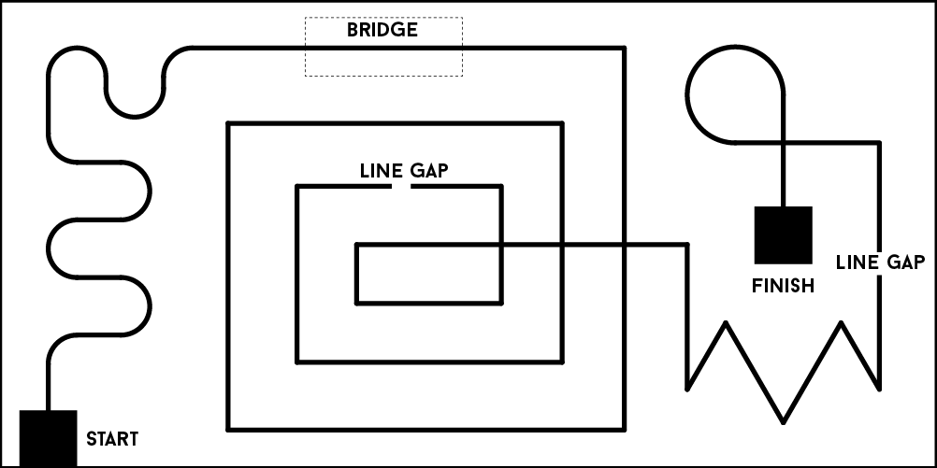

Figure 1: Primary Round

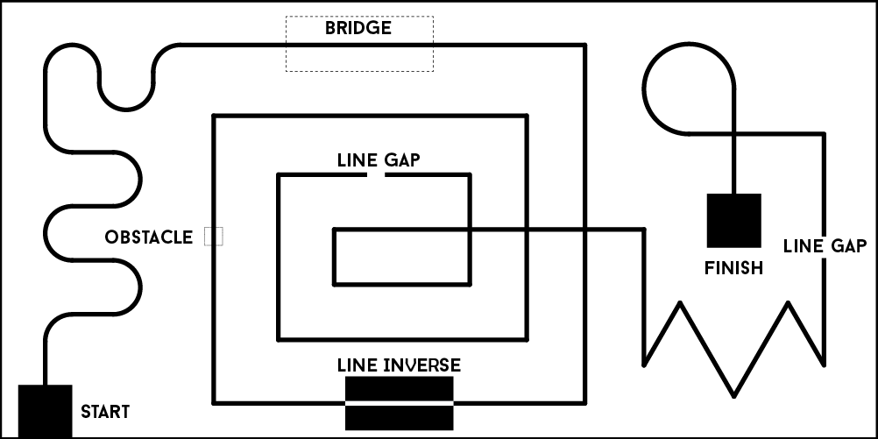

Figure 2: Final Round

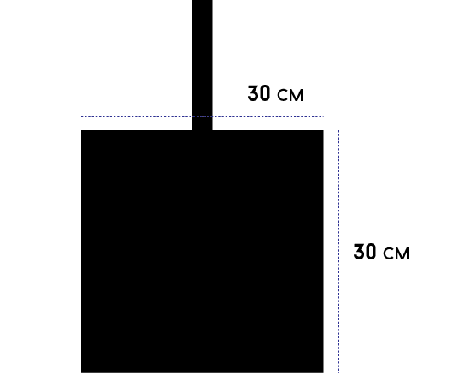

Figure 3: Start and Finish Zone

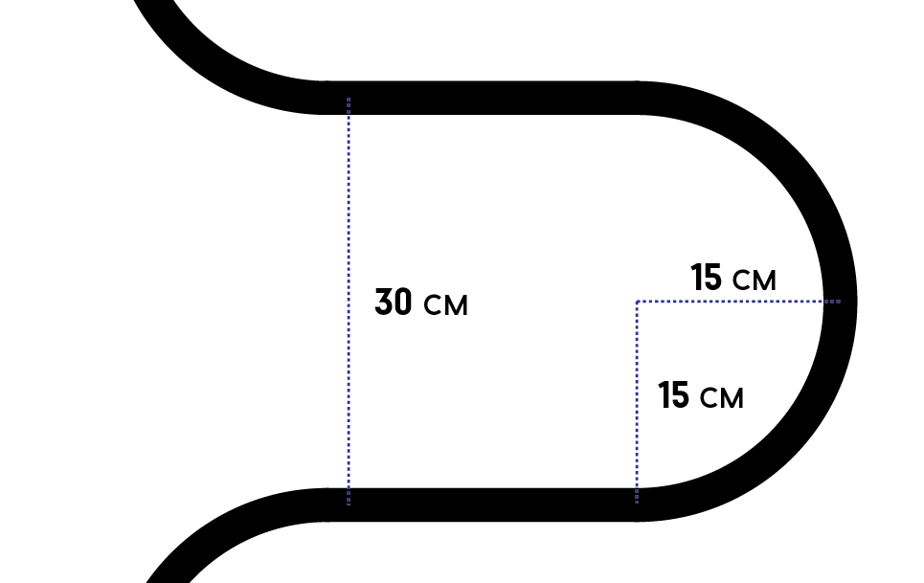

Figure 4: Curvature

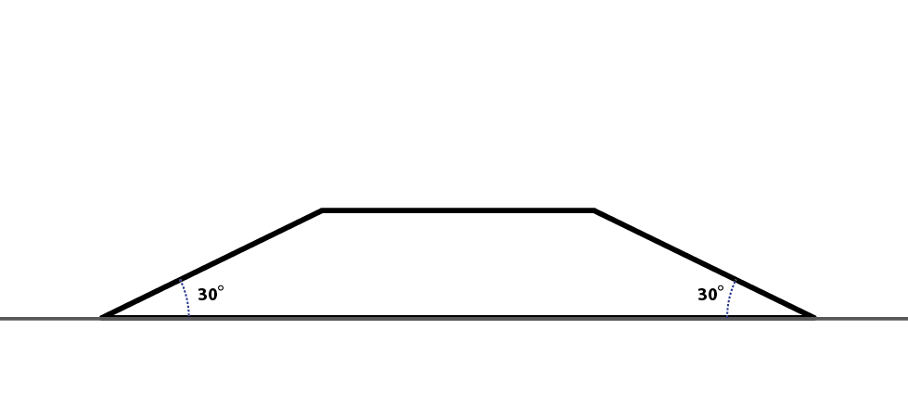

Figure 5: Bridge

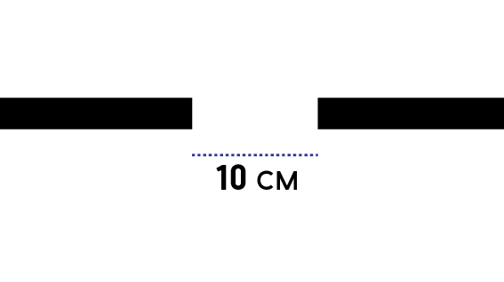

Figure 6: Line Gap

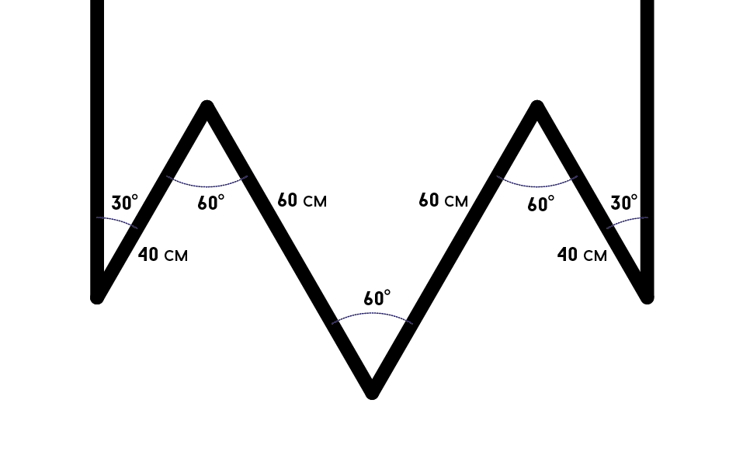

Figure 7: Zigzag

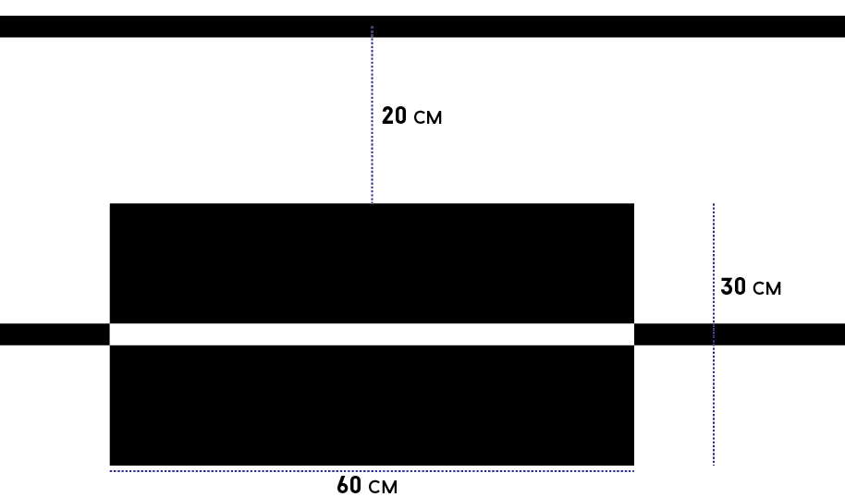

Figure 8: Colour Inverse

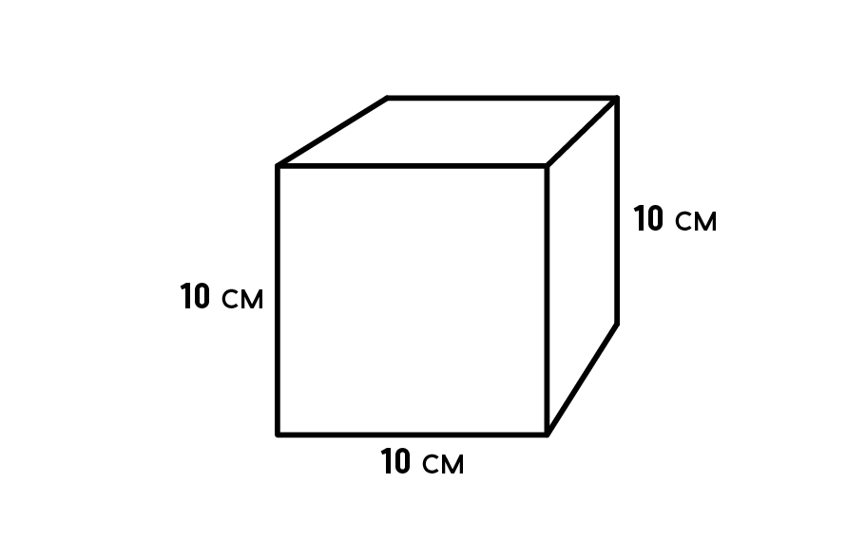

Figure 9: Obstacle

For ​ any​ ​ sort​ ​ of​ ​ query,​ ​ please​ ​ ​contact ​ ​us ​ at​ ​ ​our ​ Facebook​ ​ event page:​

<https://www.facebook.com/events/876111849233407/>